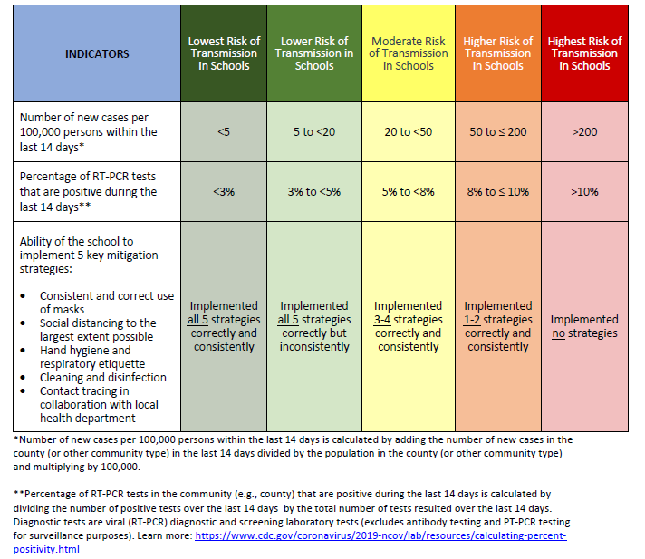

**Reference:** CDC. (2020). CDC Releases Indicators for Dynamic School Decision-Making Infographic

<https://www.cdc.gov/media/releases/2020/p0915-dynamic-school-decision-making-infographic.html>

|  |  |  |  |
| --- | --- | --- | --- |
| Date | Preventive measure | Academic Wk | Acdemic Year |
| 01-Sep-20 | * Blended learning- online or in school, maximum 50% class strength | 1 | Y1 |
| 20-Sep-20 | * Blended learning system, maintaining 30% occupancy rate * Option to continue blended learning or switching to completely distance learning | 5 | Y1 |
| 01-Nov-20 | * Compulsory attendance with 42% percent of the school capacity * Weekly rotational attendance schedule | 11 | Y1 |
| 03-Jan-21 | * School reopens after winter break, 50% rotational on-site school attendance. | 20 | Y1 |
| 21-Mar-21 | * Reduced attendance to 30% capacity * Mandatory vaccination for employees | 32 | Y1 |
| 04-Apr-21 | * 100% online classes | 34 | Y1 |
| 01-Sep-21 | * New academic year starts * Blended learning system, with 50% on campus rotation attendance | 1 | Y2 |
| 03-Oct-21 | * Full capacity, 100% attendance, with masks | 1 | Y2 |
| 01-Jan-22 | * Extended holidays due to Omicron wave | 20 | Y2 |
| 30-Jan-22 | * School reopens with 100% class strength, * Mandatory weekly rapid antigen test at home for all students | 25 | Y2 |
| 31-Jan-22 | * Vaccination campaign for 5-11 years started | 25 | Y2 |
| 03-Apr-22 | * Mask not mandatory, optional for students who wish to do so. * Continuing weekly rapid antigen test on a weekly basis for unvaccinated and non-recovered students | 34 | Y2 |